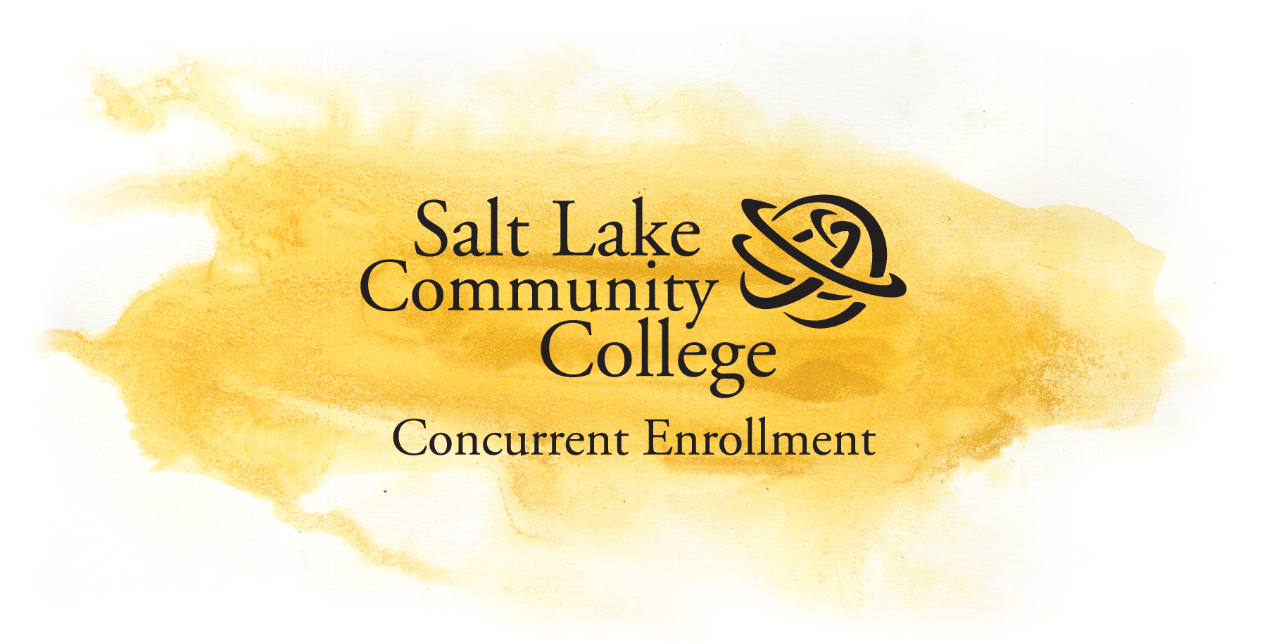
Student & Parent Memorandum of Understanding

When you applied for admission to Salt Lake Community College as part of the admission application you signed and agreed to a Memorandum of Understanding. The Memorandum of Understanding consists of very important information to help you be successful in your concurrent enrollment college classes. Please make sure that you understand and commit to what you are agreeing to.

- I am aware that the content of some SLCC concurrent enrollment college courses may include controversial cultural, religious, political, aesthetic and human sexuality issues and that I will be expected to engage with the material in an objective manner.
- I am aware that SLCC concurrent enrollment courses are college level courses and that these classes require a level of responsibility and maturity expected from a college student. This course will require rigorous academic work.
- I will be graded on a college level grading standard; no late or makeup work will be accepted without prior arrangements with the instructor.
- I am aware that regular classroom attendance and participation are a requirement, and failure to attend may affect my grade. I understand that the instructor may drop me from the class if I do not attend.
- I will be expected to create an on-line ePortfolio and submit signature assignments for my general education courses.
- I am responsible to officially drop or withdraw from classes in the event that I am unable to finish the class. I understand that I must obtain the instructor’s signature on the withdraw form and submit the appropriate form to the Concurrent Enrollment Office to officially withdraw. If I fail to properly withdraw from a college class I may receive a failing grade.
- It is my responsibility to attend a Concurrent Enrollment orientation and consult with an academic advisor to help me determine if my SLCC Concurrent Enrollment credits will apply toward the major requirements at my intended college or university.
- It is my responsibility to read and understand the student information found in the “Students & Parents” section of the CE website.
- If I am a student with a disability and have special needs or questions about my existing IEP/504 plan, I will contact my high school counselor for help.
(over)
- I understand that I am generating a permanent college record that will be applied to all of my higher education pursuits after I graduate from high school.
- I understand that my college grade and my high school grade will be the same.

Date: ____________________

Student name (printed): _________________________________________________
Student signature: ________________________________________________________

Date: ____________________

Parent name (printed): _________________________________________________
Parent signature: ________________________________________________________

